
07/01/2026
Project Image Processing
College of Information Technology
Object Boundary Extraction Using Morphological Image Processing Techniques in MATLAB

Team number: G17
Members by University ID Number and Names:
- 202402593 يزيد محمد عيسى الحاج
- 202300700محمد عمر كمال ابوخميش
- 202402687 عمر موسى سلمان أبو عنزة
- 202402595 سعد مصطفى احمد خليفات

Digital Image Processing Project Documentation

Introduction
Digital Image Processing (DIP) is an important field in computer science that focuses on the analysis and manipulation of digital images using computational techniques. It is widely used in applications such as image segmentation, object detection, and computer vision.
This project implements morphological image processing techniques using MATLAB, with the main goal of extracting and enhancing object boundaries. The process begins by converting the image to grayscale and applying adaptive thresholding to separate the object from the background. Morphological operations such as erosion and dilation are then used to refine the object and extract its boundaries by computing the difference between the binary image and its eroded version.
The results are evaluated visually by comparing the original image with the intermediate and final outputs, demonstrating the effectiveness of morphological operations in improving boundary detection.

Project Objectives
- The main objectives of this project are:
- To understand and apply fundamental digital image processing techniques using MATLAB.
- To perform image segmentation by converting a grayscale image into a binary image using thresholding techniques.
- To apply morphological operations such as erosion and dilation to refine image structures.
- To extract and enhance object boundaries using morphological boundary extraction.
- To analyze the effect of each processing step on the final image results through visual inspection.

Project Steps
- Import the original image into MATLAB.
- Convert the image into grayscale format if it is a color image.
- Apply thresholding to convert the grayscale image into a binary image for object segmentation.
- Perform morphological erosion to shrink object regions and remove small unwanted details.
- Extract object boundaries by computing the difference between the binary image and the eroded image.
- Enhance the extracted boundaries using morphological dilation.
- Display the original image along with all intermediate and final processing results for visual analysis.

Methodology:
The proposed methodology applies a sequence of image processing operations to extract object boundaries using morphological techniques in MATLAB. The input image is first converted to grayscale to simplify processing. An adaptive thresholding method is then used to convert the grayscale image into a binary image and separate the object from the background.
Morphological erosion is applied to refine the object structure and suppress small details. Object boundaries are extracted by computing the difference between the binary image and its eroded version. Finally, morphological dilation is used to enhance the extracted boundaries and improve their visual clarity. The effectiveness of each step is evaluated through visual comparison of the original and processed images.

Results & Discussion:
The following results demonstrate the effect of each processing step applied to the input image using MATLAB.
- Original Image
The original image serves as the reference for comparison. All subsequent processing is based on this image. It contains the object(s) of interest against the background.
- Grayscale Image
Converting the image to grayscale simplifies processing by focusing on intensity values. It reduces computational complexity and prepares the image for thresholding.
- Binary Image (Thresholding)
Applying adaptive thresholding separates the object from the background. Pixels corresponding to the object are assigned to the foreground, producing a clear binary mask. This step highlights the main structure of the object.
- Eroded Image
Morphological erosion is applied to the binary image to remove small details and noise. This step slightly shrinks the object boundaries and refines the overall object structure, making it suitable for accurate boundary extraction.
- Thin Boundaries
Boundaries are extracted by subtracting the eroded image from the binary image. This produces thin outlines representing the exact edges of the object. These thin boundaries provide a precise visualization of the object contours.
- Thick Boundaries (Boundary Enhancement)
Morphological dilation is applied to the thin boundaries to enhance their visibility. The thickened boundaries make the object contours clearer and more suitable for visual analysis and further processing.
- Comparison and Analysis
The effect of each step is clearly observed when comparing all intermediate and final images. Thresholding effectively separates the object from the background, erosion refines the shape, and boundary extraction followed by dilation highlights the contours. This step-by-step approach demonstrates the usefulness of morphological operations in improving object representation in digital images.

Image results and their code
- Original Image:


The Code Of Original Image:
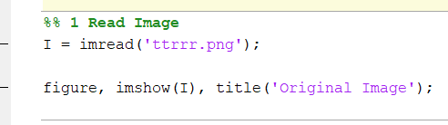

- Grayscale Image:

The Code of Grayscale Image:
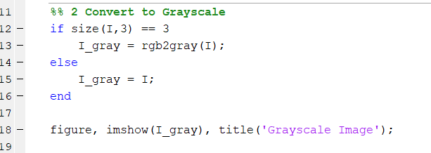
- Binary Image (Thresholding):
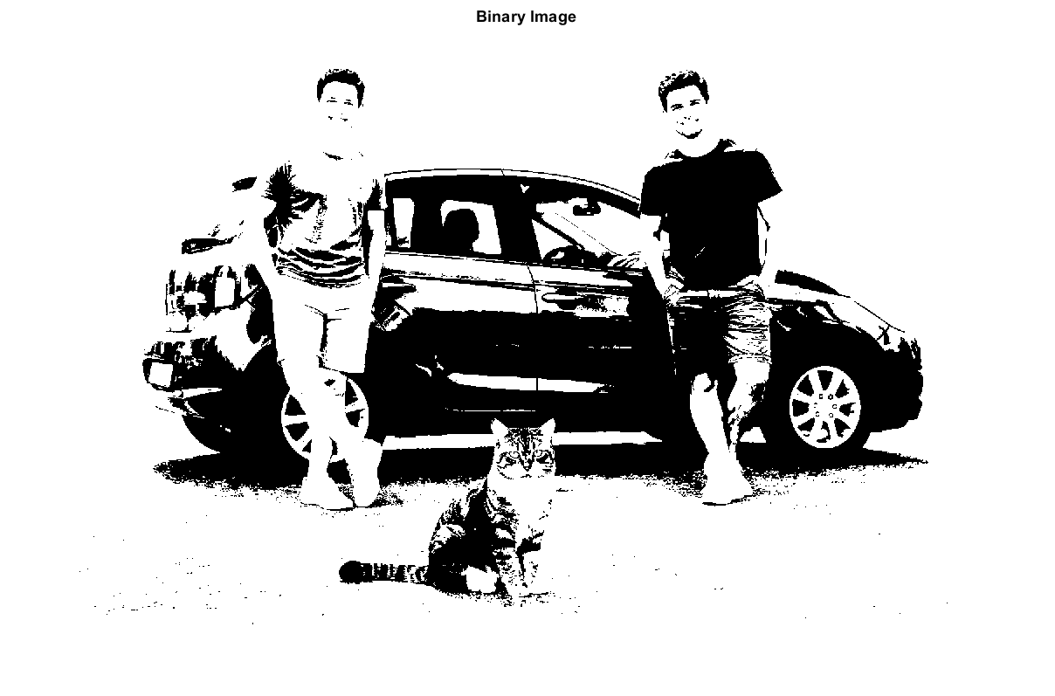
The Code of Binary Image:
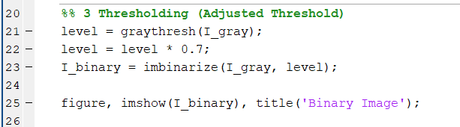

- Eroded Image
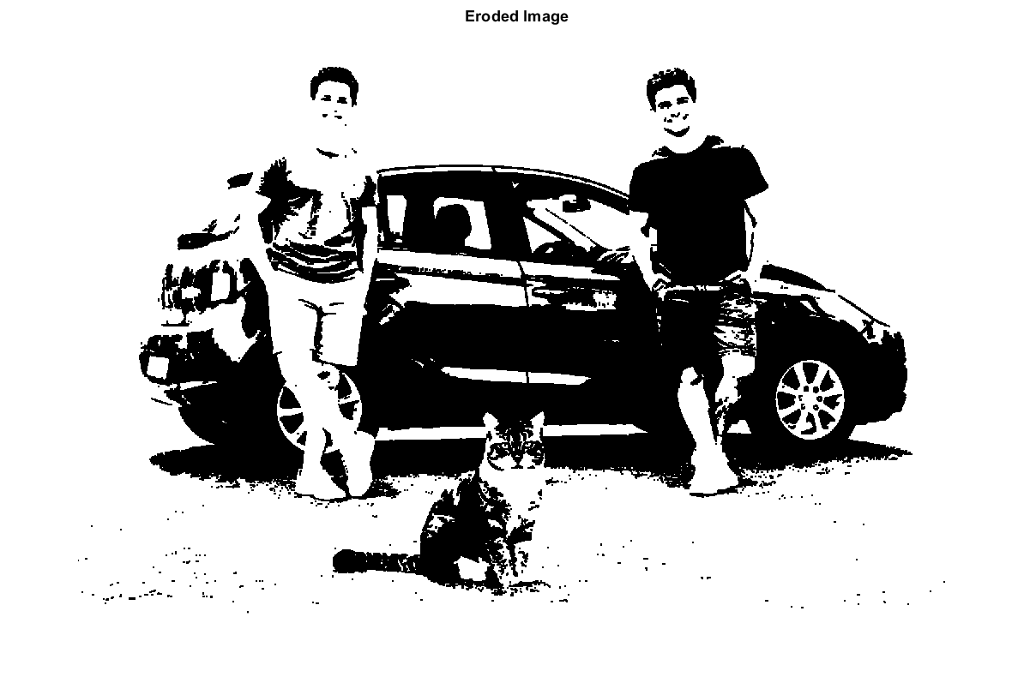
The Code of Eroded Image:
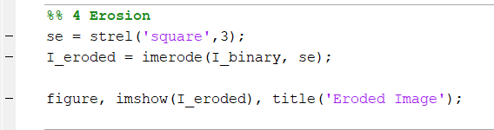

- Thin Boundaries
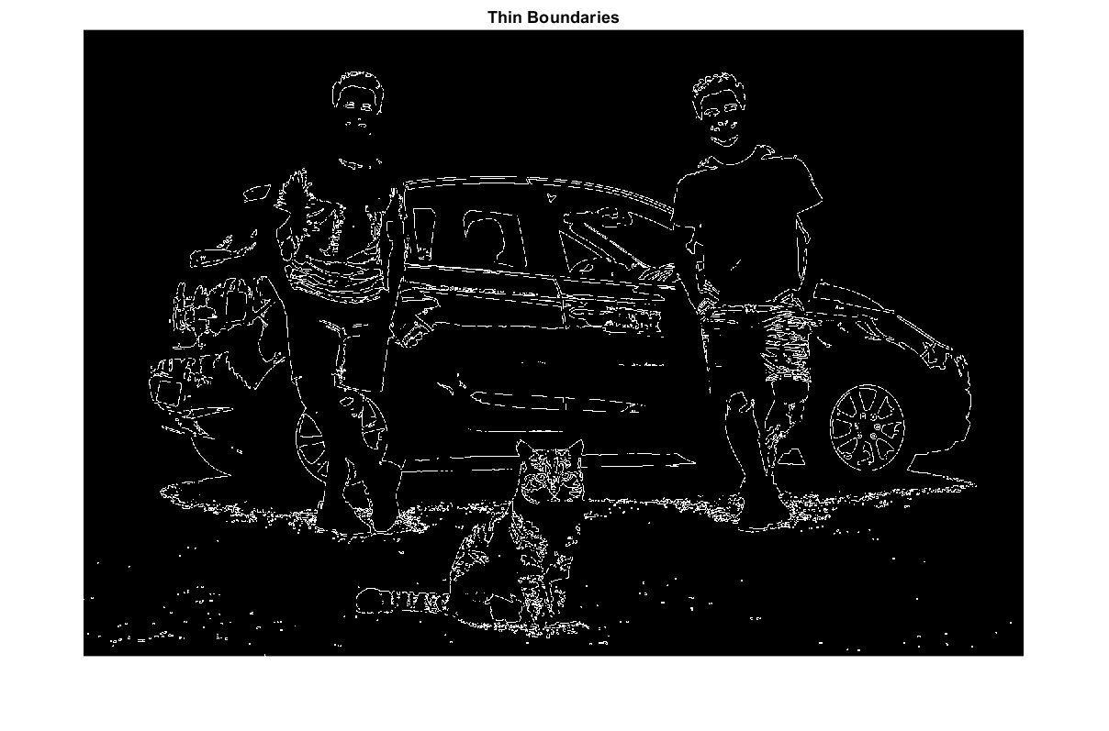

The Code of Thin Boundaries Image:
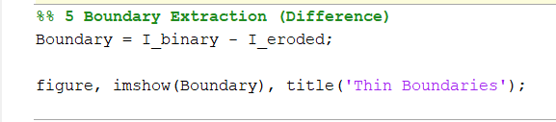
- Thick Boundaries
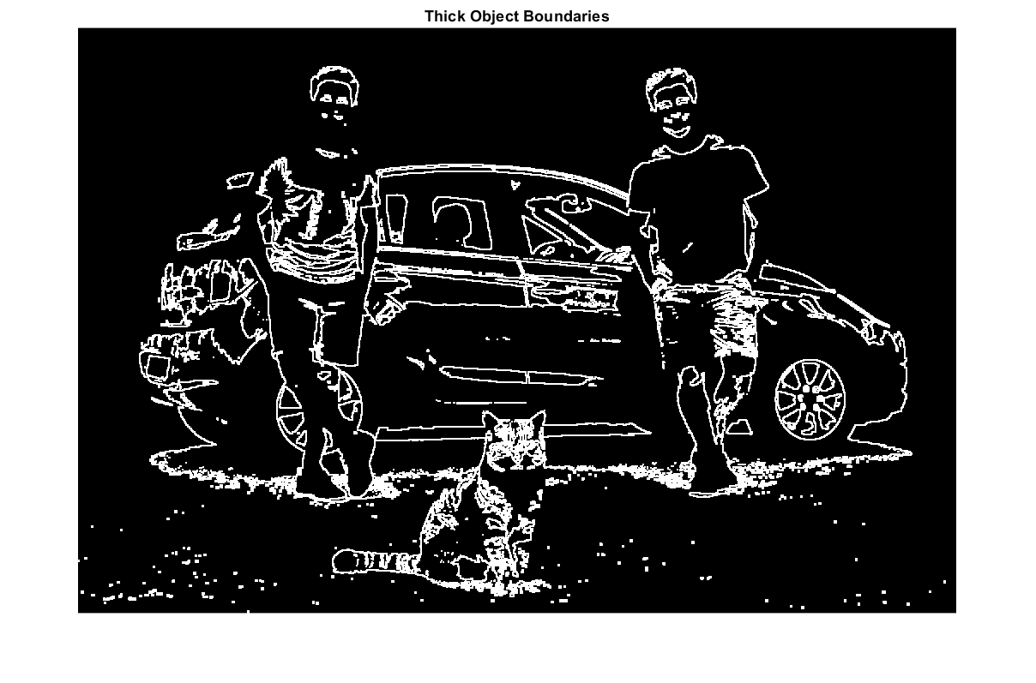
The Code of Thick Boundaries Image:
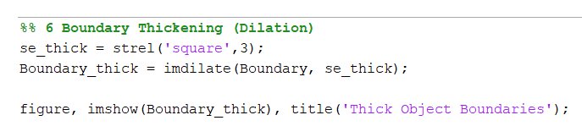
- Show All Results Together
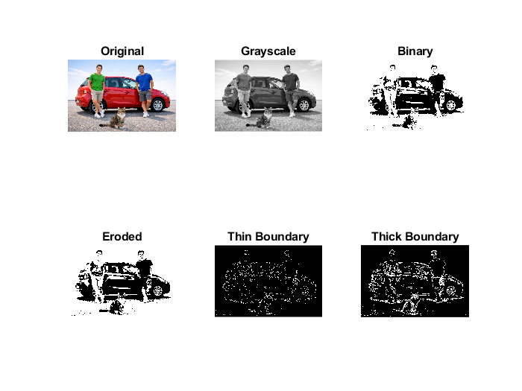
The Code of Show All Results Image:
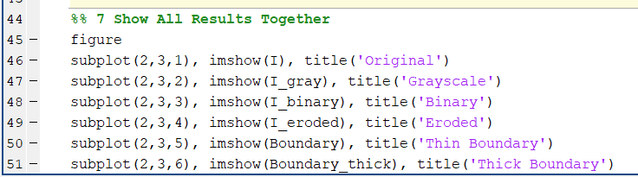
Conclusion
In this project, morphological image processing techniques were successfully applied to extract and enhance object boundaries from a digital image using MATLAB. The implemented pipeline included several key steps: converting the image to grayscale to focus on intensity information, applying adaptive thresholding to separate the object from the background, performing morphological erosion to refine the object structure and remove small noise, extracting thin boundaries by computing the difference between the binary and eroded images, and finally enhancing the boundaries using morphological dilation for better visual clarity.
The results clearly demonstrate that each processing step plays a significant role in improving the final outcome. Grayscale conversion simplified the image while preserving essential intensity details, thresholding effectively segmented the object, erosion refined the shapes by removing unnecessary details, and boundary extraction provided precise outlines of the objects. Dilation further improved visibility, making the contours more distinct and suitable for visual analysis.
This project highlights the effectiveness of morphological operations in digital image processing, particularly for tasks requiring accurate boundary detection and object representation. Such techniques are widely applicable in real-world scenarios, including object recognition, medical imaging, quality inspection, and computer vision applications where precise object boundaries are essential.
Overall, the study demonstrates that combining fundamental image processing techniques in a structured workflow can significantly enhance image analysis outcomes. The methodology used in this project can be further extended to more complex images or integrated with advanced algorithms for automated detection and analysis, making it a valuable approach for both academic and practical applications.

